**Jefferson Elementary PTA Meeting:** General Meeting

**Date:** January 28, 2025 | 6:00 pm

**Location:** MPR

**ZOOM joining info:** [**https://us06web.zoom.us/j/7602164163?pwd=ZnZFb3ZyT3FuQ2owRDJsNDk4b1lzUT09&omn=87618668048**](https://us06web.zoom.us/j/7602164163?pwd=ZnZFb3ZyT3FuQ2owRDJsNDk4b1lzUT09&omn=87618668048)

Meeting ID: 760 216 4163  
Passcode: 12345

**Attendees: Lindsey Gunson, Emma Cobb, Gracie DelMar, Lauren Crandall, Laurel Ferreira, Claire La Breche, Argenia Torres, Julie Haugen, Melissa Haskin, Melissa Glazebrook, Kevin DelMar, Josh Crandall, Sandra Cordova, Emily Sanchez, Tara Ludwig**

1. **Call to order- 6:08 pm - Gracie DelMar Quorum:yes**
2. **Reading and approval of minutes-** 
   1. General Association Meeting minutes on 9/24/24 minutes posted [here](https://docs.google.com/document/d/1uXXXL7Rr2FRk685si5kmBuiw0ue9H91HVMSB2Q63ZM8/edit?usp=sharing). Lauren motions to approve minutes as presented, Claire seconds, approved Unanimously.
3. **Principal’s Report- Emma Cobb (10 minutes) -** 
   1. Global Day of Play - February 5th
   2. Snowball Game -February 7th, open to those who want to watch, 1:15pm
   3. Coffee with Principal - February 7th (midyear data or ?)
   4. Community Day follow up - message sent in Parent Square. Event counselor ran, 4th and 5th grade and staff attended. MPR all day working on teambuilding and SEL focus. Building on “cross the line” activity to make it better for next year.
   5. Homework Support Night - very low turnout; message tonight with resources and information. Survey - 1- Parents want homework to connect with what’s happening in the classroom. 2- Parents want homework to have their kids do more homework. 3- Parents felt students were not being prepared for middle school with the no homework policy. Valley policy is homework is unfinished classwork for 6th and 7th grade. 8th has homework. SLIDE DECK BEING SENT HOME HAS THIS INFO.
   6. Next family night is Feb 27 6pm Math night! Zoom link for virtual attendance? People want to attend who have obligations. Or try something right after school.
   7. TK and Kinder round up communication? District site has info, blackboards have info, and a ParentSquare message tomorrow.
4. **IB Coordinator Report - Laurel Ferreira (5 minutes)**
   1. The Fifth Grade Exhibition has begun! Mini-lessons in classrooms. UN sustainability goals are the focus. This year, performance and creative/arts based presentations (“action project”)!
   2. This month, all classes are working on being Reflective. We learn from reflecting on experiences. “Glow”-what they did well and “Grow”-what they can do better, next steps.
   3. Training starts next week for the IB probram, 4 teachers from Jefferson are attending.
5. **Presidential Report: Gracie DelMar (10 minutes)**
   1. [Nomination Committee Vote](https://www.canva.com/design/DAGdiMh75Cs/Jr5GIjoqJQXLa0Jq4pLz5g/view?utm_content=DAGdiMh75Cs&utm_campaign=designshare&utm_medium=link2&utm_source=uniquelinks&utlId=h57454806b1):
      1. Claire La Breche, [Lauren Crandall](mailto:treasurer.jefpta@gmail.com)and Niki Reddin with Joanne Anaya as an alternate. Motion to form the committee Julie Seconded Lindsey Approved unanimously.
      2. We need a **President**, **Treasurer** and Secretary in order to exist as a PTA. Without the PTA Jefferson would not have programs like Monster Mash, Winter Wonderland or Specials like Garden and Nutrition, Art, PE.
      3. Board Positions:
         1. **President\***
         2. Executive VP
         3. VP Membership
         4. VP of Program/Events
         5. **VP of Fundraising\***
         6. **VP of Communications\***
         7. Secretary
         8. **Treasurer\***
         9. Historian
         10. Parliamentarian (appointed+ratified)
         11. Financial Reviewer (appointed+ratified)
         12. Financial Secretary (appointed-unlisted - optional+ratified)
      4. General Association Election Meeting March 25, 2025
   2. National PTA dues increased by $1, Executive Board is recommending absorb the increase as an association and not increase our membership dues. Emily motions to absorb the increase, Melissa seconds, approved unanimously.
   3. Executive Board Meetings are open meetings now. 2nd Tuesday (Exception April meeting will be on April 1st) of the month at 4:30 PM.
   4. Los Angeles Fires
6. **Garden Report** -Lindsey Gunson
   1. Garden is going great, no current pressing issues! Irrigation is a constant work in progress.
   2. Applying for grants, Sage ($5-10k), Rancho Santa Fe (up to $10k), San Diego Ag in the Classroom ($?), more pending! Click [here](https://docs.google.com/spreadsheets/d/16ZvJYRCMgnSPce-dbDEjfxHhFmxi5fdPhne0iItsidU/edit?usp=sharing). Jefferson Garden Grant Info File click [here](https://drive.google.com/drive/folders/1qzeIC_BHuT4C_dxcc7Y8IhWyt5vCvSPc?usp=share_link).
   3. Chicken team for Spring Break and Summer Break.
   4. Clubs have been, garden and makers currently.
   5. Eggs for sale in the office.
   6. Calendar idea, cookbook, beautification
7. **Teacher Report - Tara Ludwig**
   1. Jog-a-Thon email to staff has gone out, push for volunteers.
8. **Treasurer’s Report- Lauren Crandall (20 minutes) -** view [here](https://drive.google.com/file/d/1BCd9dibet0ISsznADZa8Je2WErpghL6t/view?usp=drive_link) 
   1. Motion to ratify check #s 5828-5870 - view report [here](https://drive.google.com/file/d/1df3s_XGYtqQCDDFheZbpCBR43ntVDS0j/view?usp=drive_link) 
      1. Julie motions to ratify checks #5828-#5870, Claire seconds the motion, approved unanimously.
9. **New Business Committee Reports**
   1. **Budget** - Lauren Crandall
      1. Need another 1-2 members to join budget committee with me (meet 2 times/year to review current budget and propose next year’s budget to present at May meeting) - great opportunity for next year’s Treasurer to be part ahead of taking on role
      2. Q2 Budget Update [here](https://drive.google.com/file/d/1-HpTZHiU3FOuSIbtL6IsW-0fuISiecM-/view?usp=drive_link)
      3. Budget Amendments Proposal, approved and recommended by the board:
         1. Add line item for all events to include an operating cash in/out for the $ we pull to make change for our events - will make a cleaner income/expense report if this is its own line item (typically $400-$500 for each event is what we pull then deposit separately from event income) - budget impact is $0 overall.
         2. Increase expense budget for Monster Mash by $900 , add corporate sponsor income of $1000 for MM (Mission Pest Control)
         3. Add corporate sponsorship for MCF in amount of $1500
         4. Add line item for backpack hook project expense for $4500 (one time project)
         5. Add line item within Garden for Irrigation Repairs - income $900 and expense $900
         6. Add expense budget for Bingo Night in the amount of $300.
         7. Increase Insurance Premium budget expense by $6 - adopted at $282 based on last year’s premium, this year’s premium was $288
         8. Increase IB Program expenses to include $200 for annual membership fee
         9. Shift $2000 from Club **salary** expenses to Club **supplies** expenses, leaving $10,000 in salary expenses and increasing to $2800 in supplies expenses, no expenses added overall
         10. Motion to approve budget amendments as presented above - Lauren motions, Melissa seconds. Approved unanimously.
         11. Motion to release funds for newly amended budget, not to exceed budget - Emily motions, Julie seconds. Approved unanimously.
   2. **Fundraising-**
      1. Jogathon - February 13th - see info under events below
         1. Packets go out next week. $75 per student is goal. Volunteer opportunities, pledgestar information, lots of information included in packet. Website is updated as well, schedule and loads of information. Encouragement posters for sale.
      2. Multicultural Festival - May 17th, 10 AM - 2 PM
         1. Committee Meeting touching base **Friday, February 7th** after coffee with the Principal.
         2. Coordinator Roles needed: The vacant coordinator roles are as follows:
            1. 📣 **Silent Auction - have lots of folks offering to help, but need a leader. CLAIRE LaBRECHE leading! Taking donations NOW.**
            2. 📣 Food trucks
            3. 📣 Snack Shack
            4. 📣 Paid Activities (face painters, balloon artist, henna, performances (Baile Folklorico))
            5. 📣 Games
         3. Signup sheets for committee volunteers
      3. Restaurant Night at Knockout February 6th 11-8PM!
      4. Frontwave - late March evening TBD (22nd or **30th**) at Frontwave, soccer match most likely. Jefferson would receive $6 per ticket. Tickets are $16 and up.
   3. **Events -** 
      1. Jog-a-Thon Feb 13th (Thurs)
         1. Fundraising Goal $35,000
         2. These funds are so very important to our specials–we will highlight exactly what and who these funds pay for on social media (garden, pe, music, art, etc.)
         3. Fun prizes for classroom leaders–popcorn, ice cream, pizza
         4. Donation Packets in backpacks this week!
         5. Encouragement Posters will be on sale the week of February 7
         6. Visit our Jogathon Portal for detailed information on volunteering, the running schedule, donations, purchasing encouragement posters virtually and more! <https://www.jespta.net/jog-a-thon-2025>
         7. Highlight this year will be Garden/Nutrition funding!
      2. MCF May 17th (SAT) 10 AM - 2 PM
         1. Planning committee has met–we need more volunteers to be leads (see above)
   4. **Volunteer Coordinator -** Melissa Haskin
      1. Volunteer Updates. We have the Jog-a-thon volunteer sign up ready as well as updated the Popsicle Fridays sign ups.
   5. **Room Representative Coordinator -** Jaclyn Harty
      1. Room Rep updates
      2. MCF and Jog-a-Thon updates hopefully will come out from Room Reps as well as school wide as well as teachers.
   6. **Communications -** Melissa Kirtley + Kristin Renteria + Claire La Breche
      1. Keep an eye on Parent Square for all PTA, Jefferson Elementary, and Classroom Rep communications
      2. For PTA events and other information, please visit and bookmark the PTA website <https://www.jespta.net/> BOOKMARK AND VISIT OFTEN for updates and event info.
      3. Also follow the Jefferson PTA on Instagram [@jeffersonjaguars_prowl](https://www.instagram.com/jeffersonjaguars_prowl/)
   7. **Spirit Wear -** Melissa Glazebrook
      1. Will work on new logo this year to implement next year
      2. Will be working to getting our online store functioning
      3. We will have a blow-out sale of current/old items
      4. Kids will be voting on new logo/art.
   8. **Membership -** Rae Merritt
      1. Met Membership goal for the year - always hoping to add more
   9. **Historian -** Angela Horner
      1. Log your hours! Link to form [here](https://docs.google.com/forms/d/e/1FAIpQLSdtbQS4c1YBDi3w5h_C7j5MtkMnVsI5_sqQsfDaQgwR5DT86Q/viewform).
   10. **Parliamentarian - see President’s Report**
   11. **Financial Review -** 
       1. Financial Review Committee appointment and ratification
          1. Argenia Torres, Carl Dargitz, Karina Morales, Santhana Stewart
          2. Lauren motions to ratify committee members listed above for FY24-25. Julie seconds. Approved unanimously.
       2. Mid-Year audit is ready to begin, financial records and notebooks will be handed over to the committee hopefully this week.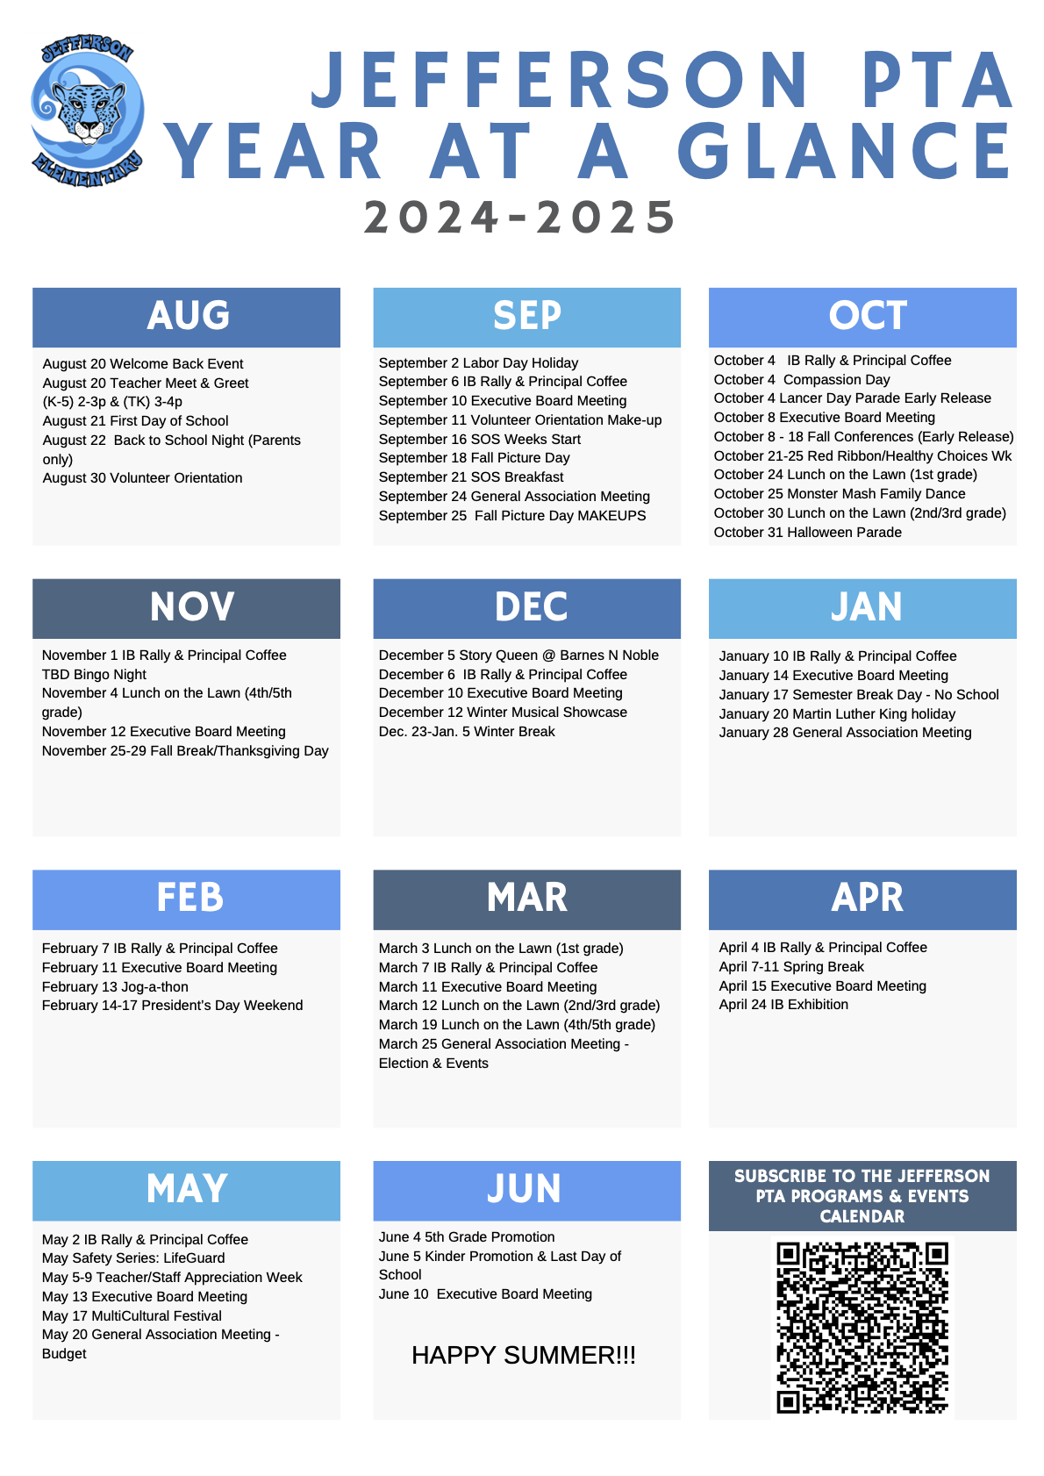

**Upcoming Dates:**

* Jan 30 - TK Round Up 5:30 pm
* Feb 6 - KnockOut Pizza Dine Out
* Feb 6 - Kinder Round Up 5:30 pm
* Feb 7 Next MCF planning meeting 9am
* Feb 7 - IB Rally and Coffee with the Principal
* Feb 11 - Executive Board Meeting
* Feb 13 - Jog-a-thon (all grades)
* Feb 14-17 President’s Day Weekend (no school)
* February 27 Family Math Night

**Meeting Adjourned: Lauren motions, Julie seconds, 7:14 pm, approved unanimously.**